How to install an Accufab Upper plenum on a 2003 Crown Victoria

DISCLAIMER: I will not be held responsible if you damage up your engine or anything else. The following worked for me and me alone on my car only. Your car maybe totally different for all I know. I am not a professional mechanic, nor do I work for Ford in any capacity. I am not an expert. This is presented as what I did to my car and you should not attempt it if you don’t have mechanical aptitude. READ THOROUGHLY BEFORE INSTALLING! Good luck!

Stuff that comes with the New Accufab Plenum
Accufab Plenum
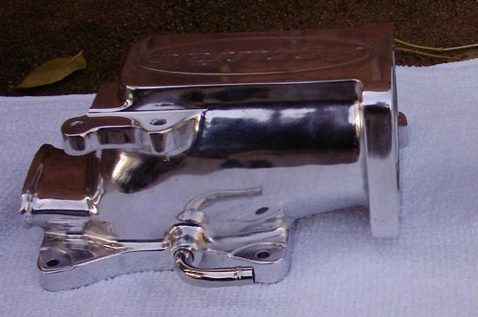
EGR gasket
Idle Air Control Valve gasket
3/8 inch vacuum connector
5/8 inch vacuum connector
Bunch of useless stickers

Stuff you are going to need
2 ft of 5/8” heater hose
1 ft of 3/8” vacuum hose
1 3/8” vacuum hose butt connector
2 6mm x 2cm bolts with washers
5/8” vacuum tee (I used brass fittings actually, couldn’t find plastic vacuum tee).
Loctite (I used red)
Whole bunch of hose clamps for both the heater hose and vacuum hoses

Tools
Ratchet
6mm socket
10mm socket
Rubber mallet
Grinding wheel (You are going to have to grind something down)
Cutting wheel (I used a Dremel for grinding and cutting, worked well)
Hi speed drill (I used a Dremel for this too, you’ll see why)

One thing that I strived to do is to not alter or cut any stock parts. My car is still under warranty so I wanted to make sure I could swap the Plenum back out without buying new parts to make it look stock.

If you look at the new plenum you will notice right away that the vacuum fittings are in different locations.
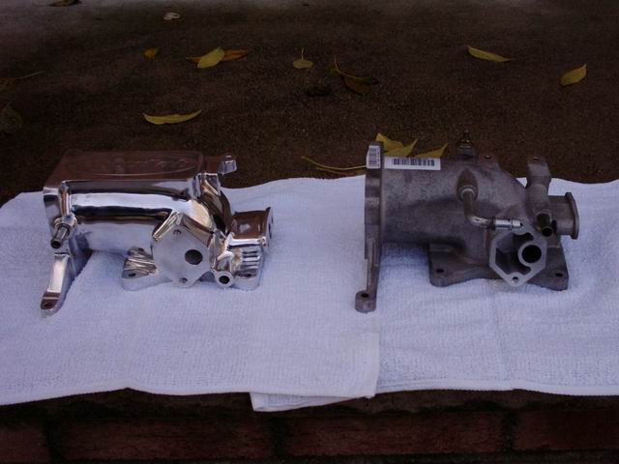

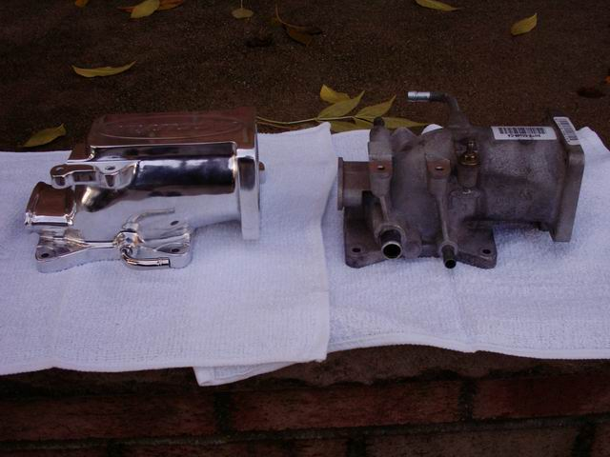

Hey wait, this side is missing a vacuum port! Yep, your damn skippy it’s missing one.

That’s not all that’s different;
- EGR valve is lower.
- EGR valve is at an angle.
- IAC valve is 3/4” closer to the throttle body
- Although the throttle linkage bracket is mounted in the same location relative to the throttle body, the bolts for the Mustang bracket are closer together, hence the drill.

Remove Old Plenum
Well first thing, take off the old plenum.
- Take off the engine cover.
- Remove the intake hose.
- Unplug the IAC valve and TPS.
- Remove the throttle linkage bracket and remove the throttle cables and spring from the Throttle Body.
- Remove the two forward and two rear vacuum hose connections.
- Unbolt the EGR valve. A metallic EGR gasket will drop out. SAVE THAT GASKET, you are going to re-use it.
- Unscrew the plenum bolts and lift that it off.
- When the plenum is out of the car, remove the throttle body and the IAC valve. Be nice to that IAC valve, they are pretty finicky.

Now for ease of explanation I will tackle each issue separately.

PCV Hose(s)
The PCV hoses. I would recommend clamping every connection. This will take about seven 5/8” heater hose clamps.
- On the passenger side, remove the elbow connecting to the old plenum. Turn the plastic tube that is still attached to the valve cover, that was in the front of the plenum, turn it behind where the new plenum is going to go.
- Connect the 5/8” heater hose to the passenger side tube. Route it to the driver side. Be careful to keep it away from any heat sources, such as the EGR tube.
- On the driver’s side, remove the stock driver side hose at the valve cover, but leave the rubber elbow attached to the valve cover.
- Insert the 5/8” tee into the driver’s side elbow and the hose coming from the passenger side. You will have to cut that hose down from the 2’ length.
- Remove the hose from the plastic elbow going into the air intake tube. Take a section of hose from step 4 or the previously discarded driver’s side rubber hose and connect to plastic elbow at the intake tube.

Picture of the PCV hose/tee
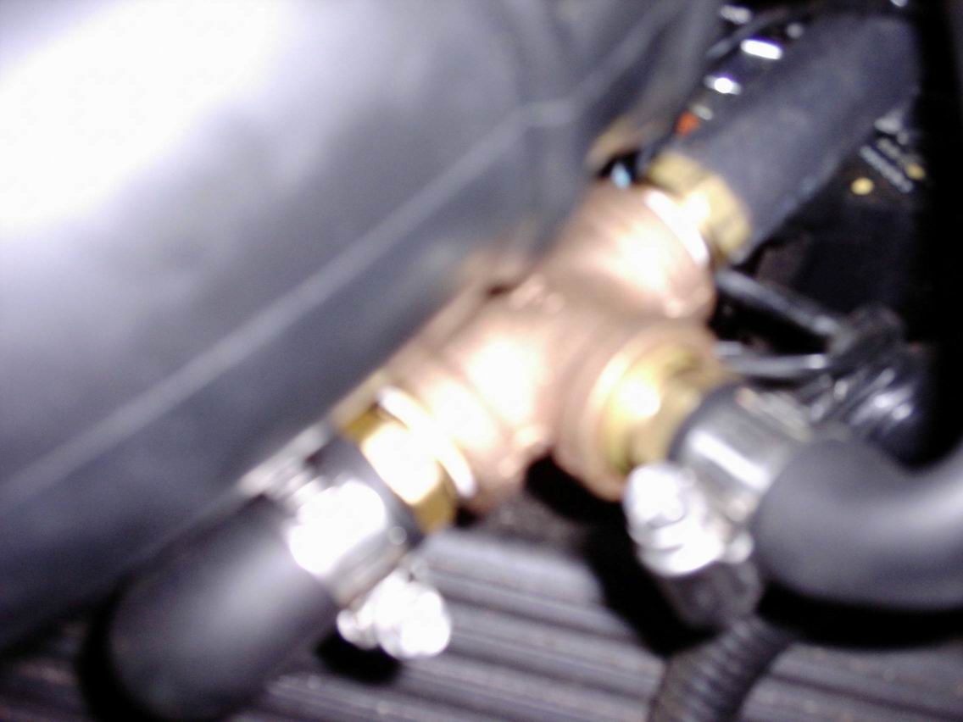

Other vacuum connections
- Front vacuum connection. You are going to have to cut the new plenum’s front hose, because it points to the driver’s side and you need a straight connection.
Cut it right about here with your cutting tool.
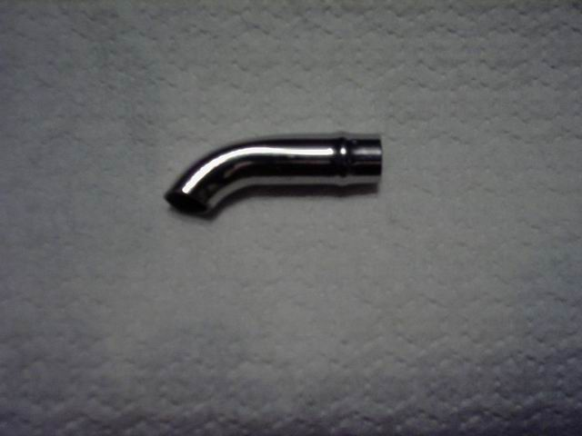
This is what I cut off the Accufab

- Put the Fuel Regulator vacuum hose on, but be sure to use a hose clamp to get a good seal. You don’t want this one leaking.

Rear vacuum connections;
You have a choice of inserting a large vacuum connector or small one.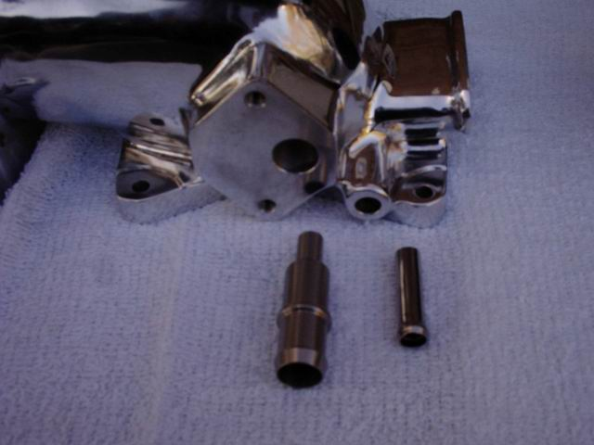

- Put a dab of loctite on the smaller connector and tap it in nice and slow with the rubber mallet.
- Connect the other vacuum hose to the butt connector and the 1’ ft section of ½” vacuum hose. These vacuum hoses are ready to go.

Pretty easy so far, huh? Not so fast…

Throttle linkage bracket
This is where it gets sticky. Now I know my pictures kind of suck but bear with me here. My digital camera isn’t the best.

Here is the bracket before:
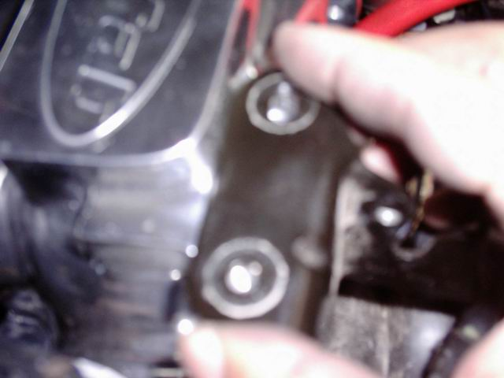

There is too much metal to the left of the holes. Also, the bolt holes on the Accufab plenum for the throttle linkage bracket are for a Mustang, so they are too narrow for the Crown Vic.

Get out your grinder and drill
- Remove the throttle linkage cables from the bracket.
- With your grinder, take about an 1/8” of metal off the entire left edge bracket to the left of the holes as shown above.
- With your drill or dremel elongate the driver’s side bolt hole (It is already oblong from the factory) about a ¼” further in towards the other bolt hole.
NOTE: DO NOT MODIFY OR EVEN TOUCH THE PASSENGER SIDE BOLT HOLE! This is, for lack of a better term, a reference bolt. If you make a modification to this bolt, you could either screw up your idle permanently or add some slop to the throttle linkage.

Pic afterward. Yeah, this pic sucks too.
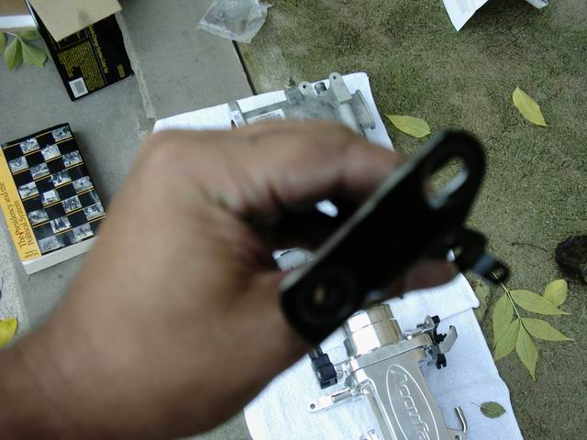

Install the new plenum
- Mount the IAC valve on the new plenum. Use the new 6mm X 2cm bolts you bought. The stock mounting bolts bottom out in the plenum. Use the new gasket that came with the plenum. Tighten to about 88 in-lbs.
- Mount the throttle body to the plenum. You can use the old gasket if in decent shape. Make sure that the gasket does not extend into the airway. If it does, make the hole in the gasket larger. I had to cut an 1/8” inch out of the gasket all of the way around so the gasket would not stick in to the airway.
- Mount the plenum to the intake manifold. Cross torque the 5 mounting bolts to 71 to 106 in-lbs.
- Attach the rear vacuum ports. Attach the front vacuum port. I would put a clamp on the front vacuum port.
- Torque down the EGR valve slowly and evenly. The new plenum has the EGR mounted about a 1/2” lower and at an angle, just a degree or so. This is not really a problem except to say that if you put on one full turn at a time on each bolt, the EGR valve should seat itself against the mating surface evenly. Use the old metallic spacer gasket. Mine was a restrictor. Torque down to about 18 ft-lbs. I did not use the gasket that came with Accufab plenum, it did not look up to the task of holding up to hi-temp exhaust gases.
- Reconnect air intake hose. The bypass hose that goes to the IAC is about ¾” too long relative to the mounted position from the old plenum and IAC valve. To solve this I just forced the elbows on each side of the plastic tube on another ¼” or so.
- Attach the cables and spring to the Throttle Body. Mount the throttle linkage and bracket to the plenum.
- Throw the engine shroud or cover into your basement, unless you want to figure out how to re-mount it. Personally, I think that chrome plenum looks awesome on the top of the engine.
- Plug in the TPS and IAC.

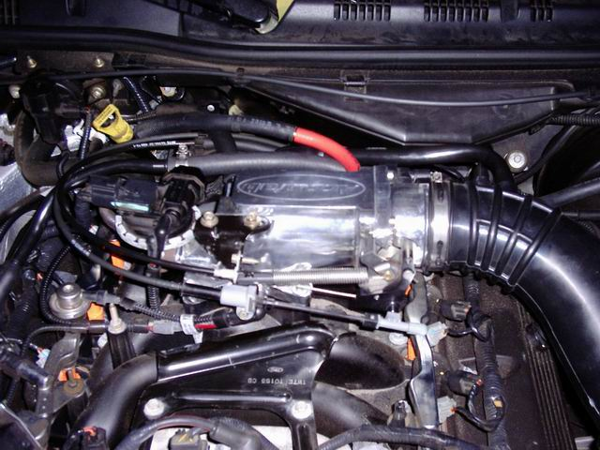

Congratulations! You have installed a Mustang performance part onto your Crown Vic!

Those friggin’ Mustang guys shouldn’t have all the fun.

